# Failurists: Methodologies, Motivations and Meanings

## Introduction: Locating Uncertain Futures

The idea of the Failurists Collective was born out of a creative methods workshop at RMIT Europe in Barcelona in 2018. We were an interdisciplinary group of researchers and practitioners interested in how we could recalibrate the role of critical-creative methods in relation to social justice and the climate emergency context. This workshop was a window in time before the ‘unprecedented’ European heatwaves, the catastrophic bushfires in North America and Australia and prior to the COVID-19 pandemic. Recognizing our implicit culpabilities and vulnerabilities, the sense of urgency to ‘do something’ creatively and critically engage with this reality was palpable in the workshop.

The exercise was more than just a social innovation agenda. This workshop was about stretching disciplines, techniques, methods, and knowledge translation for new ways of knowing that allowed for vulnerabilities and subjectivities to emerge as part of failing as an act of liminality and deep reflection (see Figure 1.1). For example, the way in which an ethnographer, if one listens deeply to the field, then transforms the preconceived research questions through their failure. In what ways could ‘pivoting’ be framed as an iteration in which codesign and cocreation with the field is a constant process of failing, translation, and recalibration?

Figure 1.1: Creative Research Methods Approach to Failure. From 2018 RMIT workshop.

Indeed, just the act of conversation between the disciplines is an action of constant translation, failure, and adaptation — take, for example, how elastic the term codesign has become across the disciplines and sectors. For some it means ‘I spoke with an end-user’; for others it is a constant cycle of discussion, debate, translation, and transmission. As a collective, we explored various modalities of workshopping — its potentialities and limits to create and curate playful iteration and recalibration.

Since 2018, significant climate-related events in the world at large have demonstrated that failure is ubiquitous within and across our human systems. And, in turn, disenfranchised (unacknowledged) grief hangs palpably like a heavy cloud, a distress now coined by Glenn Albrecht as solastalgia – an ill feeling one experiences when they are powerless and impacted by significant environmental changes and impacts.[1] David Kessler, who with Elisabeth Kübler-Ross, explored the initial five stages of grief, defined the COVID-19 pandemic as adding another layer of grief — that of uncertain futures.[2]

However, for many, this uncertain future in a time of climate urgency has been a long time coming. So much so that when we hear of heat waves in London of 40 degrees Celsius and the heat dome in the Canadian town of Lytton (which led to unprecedented temperatures of nearly 50 degrees Celsius before a wildfire ignited and razed the community to the ground), we know that it’s more than just a climate emergency. Climate change has always been more of a communications and engagement crisis than an environmental one.[3]

## The Unprecedented Precedent: Care, Worlding, and Different Ways of Doing

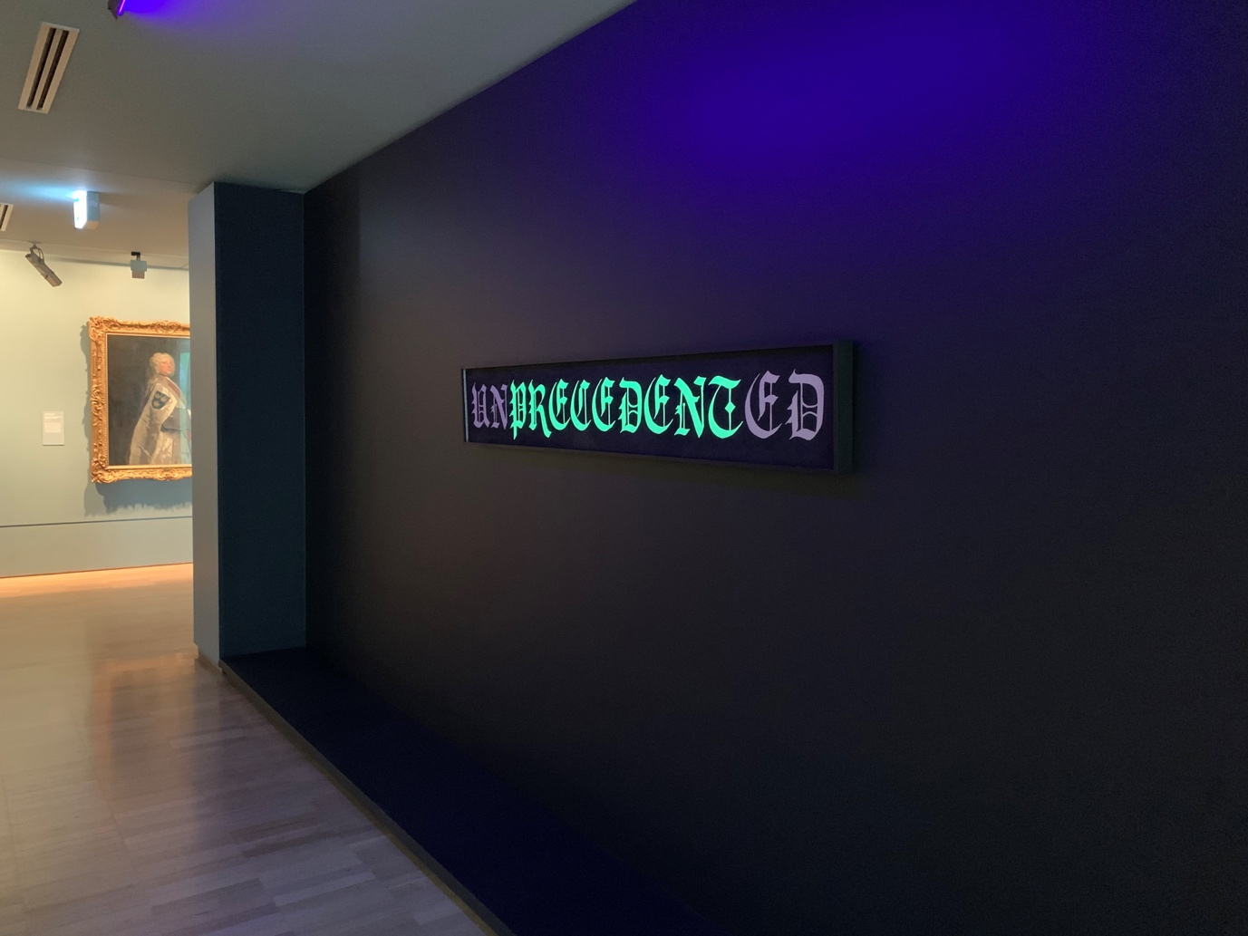

Figure 1.2: Megan Cope (2020) *Unprecedented* 2020. Courtesy of the Artist and Milani Gallery.

Indigenous Australian Qunadamooka artist Megan Cope’s UNPRECEDENTED (2020) is a wooden board sign in old English script. Made from ochre, burnt Bundjalung country (charcoal), and glow mineral, the word initially reads PRECEDENT. This work is a powerful statement on what has now become precedent — unprecedented. With the increasingly climate change-related natural disasters of fires, floods, and pandemics, the word ‘unprecedented’ fails to capture the complex layers of material, social, and environmental dimensions facing the globe. In the emptying out of unprecedented to become precedent, it has become apparent that we need to change how we do things. Indeed, in the face of such tremendous failure, many have turned to the Indigenous ways of doing, being, and knowing as a more sustainable way for the world in the face of Anthropocentric disaster. How we work equitably with and alongside First Peoples is of upmost priority in these critical unprecedented times, recognizing that many contemporary concepts around sustainability, kin, and futurisms draw from complex Indigenous cosmologies, which are sometimes acknowledged but frequently not.

The failure of the Anthropocene — in which human-centeredness has led to destruction of the environment — has meant that many are rethinking how we relate to and ‘make’ the world, or what multispecies scholars call our ‘worlding’. Worlding is a phenomenological concept which describes a move away from divisions between subject and the environment to instead focus on the *temporal,* *spatial,* and *corporeal relationality* of being-in-the-world. Fundamental to this approach is how human-animal relations figure in practices of caring — for ourselves, our others, and the worlds we make.

For Donna Haraway, the failure of science and technology in exacerbating rather than providing solutions to ecological destruction challenges us to ‘radically rethink’ the relationship between humans and nature, and dilate our sense of affinity, responsibility, and care to encompass animals as co-evolutionary ‘kin’.[4] According to Gavin Van Horn et al., we need to radically revise the relationality between humans and more-than-humans in terms of kinship and kinning.[5] How might multispecies theory contribute to media and cultural studies to enrich our understanding of this kinship across social, digital, and material worlds?

Care is a complex layering of affect that is often entangled with practices of surveillance and guardianship, both social and benevolent.[6] Over the last decade care has become an important space and concept, particularly for feminist research by feminist scholars including Annemarie Mol[7], Puig de la Bellacasa[8], and Haraway[9], who directly explore care relationalities with emphases on media, technologies, and more-than-human agency. As an historically ‘feminized’ concept, care has many dimensions and modes of affective labor and pastoral guidance which have often been devalued. The COVID-19 pandemic as a global phenomenon transgresses isolated geographies or nation-states; it has centralized care as a matter of survival in profoundly visible ways that has forced rich and powerful nations in the Global North to bear witness to their own vulnerability and failures of equitable care and governance.

Focus has turned to ideas like more-than-human kinship[10] as a way to recalibrate how humans co-inhabit the world. More-than-human relations have been the ongoing focus of several multispecies and animal studies scholars including Haraway[11], Anne Galloway[12], Thom van Dooren[13], and Eduardo Kohn[14] among many others. Their research actively challenges human-centric approaches to ontology, agency, design, and ethnographic research, providing alternative ways of thinking about our being-in-the-world. So much so that now there is a call for critical failure studies as a way to encompass and challenge norms of success as part of neo-liberal regimes.[15]

In this way, failure is deeply embedded in our vulnerabilities. It is intrinsic to how we learn, adapt, grow, and die. It emphasizes the need to enhance our sensory experiences of the world and to acknowledge the powerful role of smell, touch, and proprioception in our interpretations of and feelings about the world. And while there has been a lot of celebration of failure in entrepreneurial technology speak (‘fail bigger and better’), at the core of failure is to be reflexive to the reality of humanness. For some, failure is not just an experiment — they don’t have the privilege or power. Scholars in feminist science and technology studies (STS) and multispecies and environmental humanities have long been fascinated by the role of failure in methodologies, conceptualization, and ways of being in the world. It can help us conceptualize concepts such as grief as not neo-liberal individuated feelings but as part of a cultural fabric that helps us reflect and learn from experience (rather than just repeating the same mistake again and again).

Figure 1.3: Critical making in the 2018 Workshop. Photo: Larissa Hjorth.

## Failure as Creative Research Practice

Failure is a popular topic *of* research. It has long been a source of study in fields such as sociology and anthropology, STS, privacy and surveillance, cultural and media studies, art, theatre, film, and political science. When things go awry, breakdown, or rupture they can lead to valuable insights into the mundane mechanisms of social worlds.[16] For instance, Susan Leigh Star has argued that essential infrastructures — such as for water or electricity — are often overlooked and under-appreciated until something goes wrong; breakdown reveals behind-the-scenes activities ordinarily taken for granted.[17] And as Luke Munn argues, failure is now ‘designed into’ the ‘resilience’ of data center infrastructures — rendering them operational imaginaries for future possibilities through enactments in the present.[18]

Yet, while failure is a familiar topic *of* research, failure *in* and as a tactic *of* research is far less visible, valued, and explored.

Research failure rarely features in finished scholarly and artwork. More often, it is cleaned-up in the final polished argument or piece. When it does appear — often in the form of mess, mistakes, and mishaps — it is framed as unexpected problems to be solved or navigated around, such as the ‘confessions in the field’ genre.[19] Ethnography has a long tradition of disclosing moments of failure in the field as breakthroughs.[20] While providing fascinating insights in the realities of research, failure of this type rarely challenges methodological practices, data collection, analytic teachings, or normative research outputs. We seldom learn from them — except to avoid whatever happened from happening again.

In conventional methods textbooks, failing is largely presented as the result of poor preparation and execution. It is written of in terms of what-not-to-do and workarounds via a plethora of techniques for erasing awkward data and resolving problems and closing down the unexpected and tangential. As Christine Hine critiques: ‘Our methodological instincts are to clean up complexity and tell straightforward linear stories, and thus we tend to exclude descriptions that are faithful to experiences of mess, ambivalence, elusiveness and multiplicity.’[21] Another type of failure in research resonates with popular tech-entrepreneurial discourse. Here, failing is viewed as heroic, individualistic, and heteronormative in tone, and often instrumentalized as part of a linear success story. Some, like Appadurai and Alexander, argue that this kind of failure is blind to conventional tropes and, as such, ‘produces and sustains cultural fantasies and regimes of expectations.’[22]

Here we seek to argue that failure isn’t the opposite of success — rather it is a productive way of being in the world that acknowledges the inequalities, contingencies, subjectivities and collaboration in, and with, the field. Drawing from stories in the field, we explore how to think and write about failure in ways that acknowledge it as an important part of the researcher’s journey — from being reflexive in the field, to designing in contingency through iteration, to how to understand social impact in dynamic ways.

The authors in this collection are also interested in usurping the idea that failing is only possible for the successful, beyond the precarity of academic life. Instead, by attempting to reclaim failure, in multiple forms, we want to ‘escape the punishing norms that discipline behavior and manage human development’ and which ‘clean boundaries between […] winners and losers’.[23] We are open to practices of failure that de-link from conventional systems of knowledge and research practice. Taking a decolonizing approach, we set out to rethink and rework failing in research in terms of the enduring power and influence of ‘imperial legacies of Western knowledge and the ways in which those legacies continue to influence knowledge institutions to the exclusions of Indigenous peoples and their aspirations’.[24]

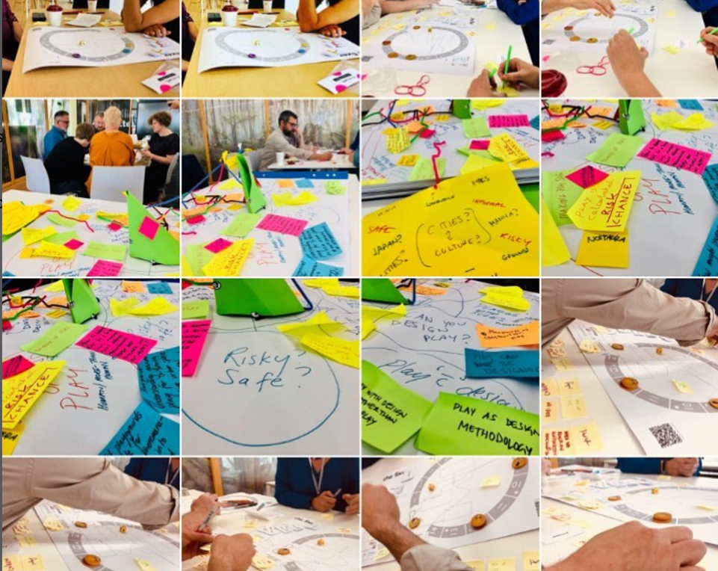

Figure. 1.4: Images from the workshop. Photo: Larissa Hjorth.

## Failure as a workshop

As mentioned, this book emerged from a critical making workshop hosted at RMIT Europe in July 2018. While the primary theme was failure, it was designed to discuss best practices for creative, impactful research methods.[25] Led by Larissa Hjorth, it featured 11 interdisciplinary researchers from a wide range of disciplines including sociology, anthropology, geography, STS, game studies, digital media, design, and creative arts. They travelled from Aarhus, Barcelona, Leiden, London, Madrid, Manchester, and Melbourne. Everyone was asked to present on the following questions:

* How has my work or method failed in a particular project?
* What do we learn from failure?
* What are some of the habitual failure expectations we make when we design our research?
* How does failure play into the process of creative research design and practice?
* How can we think about doing impactful methods and what are some of the failures?

The goal of this workshop was to explore experiences of research failure and build conceptual understandings of and practical solutions for innovative creative methods that address challenges in doing collaborative, interdisciplinary work. Through a series of scenarios and examples, we mapped it as a generative space for recalibration, adjustment, and attunement. These examples were then discussed in terms of various contexts: understanding and working with failure for students; with peers and partners; and future interdisciplinary collaborative scenarios. Together we explored various tropes around failure — not just as a creative opportunity for recalibrating methods, research questions, and external expectations, but also as a way of knowing the world, and, most importantly, failure as a vehicle for critiquing larger issues around the challenges of the academic landscape.

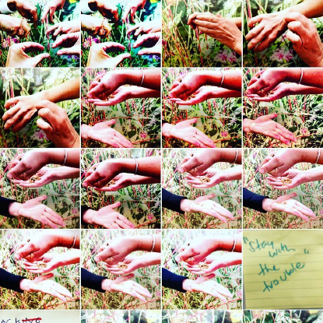

Figure 1.5: Workshopping “Staying with the trouble” 2018. Photo: Larissa Hjorth.

## Failurists Collective

This collection has emerged out of continued conversations sparkled by the initial workshop. It features several of the participants and more colleagues around the world. In the following pages, interdisciplinary researchers and practitioners share their practice, insights, and challenges while discussing key tropes in the failurist taxonomy (see Figure 1.5). Disciplines are even more diverse: architecture, digital arts, cultural studies, design, media studies, sociology, and STS. Everyone was asked to reflect on the following questions in relation to failure in their own research:

* How can we be more faithful to failure in research?
* How might failure in research be viewed as a form of disciplined undisciplining?
* Can failure be a tactic for wielding, unraveling, or enabling different kinds of power?
* Can failing uncover hidden heteronormative and colonial systems of oppression?
* How, when, and why should researchers hold onto, value, or argue for failure?
* How might failing help us to think, feel, see, smell, speak, act, and know differently?

Together we reflect upon the role of creative interventions as a critical mode for methods, research techniques, fieldwork, and knowledge transmission (to publics). Here, failure is considered a productive part of engaging *with* and *in* the field. It is about acknowledging the ‘mess’ of the social and how we need methods, modes of attunement, and knowledge translation that address this complexity in nuanced ways.[26] We organize this eclectic mindhive for thinking and feeling through failure and failurist actions in four sections: Section I: Digitality, Archives, and Design; Section II: Care/Activism; Section III: Creative Critical Interventions; and Section IV: Play and the Senses.

The sections are dynamic and seek to coalesce various ways of thinking about the concept and practice of failure. The sections weave in different subjectivities, relationalities, and positionalities — rhythms reflecting the numerous material, social, and digital encounters. Each subtheme is an invitation to probe certain areas of failure in all its complexity; an invitation to sit with someone’s own lived experience of failure and how it manifests in research practice and theory. What does failure mean? What does it do? What does putting failure under the microscope do to our assumptions around ontology and epistemologies? How can it be deployed to challenge norms in a time of great uncertainty, crisis, and anxiety? And what are some of the ways resilience and failure are interrelated?

We begin the book with the Section I: Digitality, Archives and Design*,* which discusses classic sites of failure in research. While the fields of digitality, archives, and design can broadly encompass many things, this section spans research *with* and *on* computers, patent archives, mobile phones, social media, and big data. Few researchers would be without a story of malfunction, loss, or disruption of some regard to these kinds of essential tools or sites designed to host, support, or enhance research practice. Our perspective on failure goes beyond the usual breakdown, complicating the normative binaries of success or failure, to deliberately blur the idea of something working or not working. Although moments of crisis might catalyze an initial happening, authors in this section collectively ‘stay with the trouble’ of the unexpected, while simultaneously broadening learnings and insights far beyond the immediate unfolding issue.[27]

The authors in this section share and discuss failure in classrooms, museums, archives, on screen, and in ethnographic fieldwork. They explore it in relation to professional contexts and personal experience, in the present and in the past. And they ask questions, reflecting on the feelings and learnings, the impacts on others, and how failure shapes research planning, questions, and outputs.

We start with Jessamy Perriam, who shares her experiences of researching Instagram, hashtags and selfie sticks in ‘Making Friends with Failure in STS’. She reflects on ‘rookie errors’ in past projects, learnings in practice and what happens when ideas develop along the way. Rather than feeling embarrassed or pressured to make a failed experience productive, she discusses attempts to make friends with failures, and asks: ‘How do we think about them not as offcuts of the research, but as a part of our narrative as researchers?’

Emma Fraser and Clancy Wilmott’s chapter ‘‘No Device Found’: Failure and Frustration in Critical Digital Methodologies’ starts with the premise of problematic digital media. Many devices and systems are always in a state of needing updates, maintenance, and ongoing care and repair. The authors reframe the media and mediums in their practice, shifting perspectives from what they call ‘perfect machines with imperfect users, to imperfect machines: glitch-filled, design-limited, dust-ridden, bound by bodged code, and held together by loose connections’.

Kat Jungnickel then takes us into patent archives to investigate data riddled with gaps, erasures, and silences in ‘Patent Failure, Researcher Failure, Archive Failure: Getting Inventive with the Study of Inventions’.She focuses on what archives reveal and conceal and explores failures from three perspectives: inventors and inventions, researchers and research, and the archive itself. Throughout, she explores different ways of getting at data that may not be there and ‘questions the politics that shape collections’.

In ‘Failure as Reflexive Method to Think Otherwise’,Annette Markham explores the common view of failure as something bad, negative, or the opposite of success. She discusses how these perspectives can be socialized into researchers, moving from an experience into a personal attribute and can be difficult to shift. By exploring ideas of failure in and outside academia she sets out to ‘build the conceptual notion that failure is nothing more or less than an outcome of an experiment or action’.

Everyday memory and forgetfulness in terms of gendered research and ethnography is central to Anna Hickey Moody’s chapter ‘Digital Agency and the Authorship of Failure’. She focuses on the ‘politics of feeling like a failure’ and how this can shape, and be shaped by, gendered research experiences. Examples of this might be when researchers get locked out of devices, get hacked, or lose data in different ways. She asks: ‘how we can reclaim and articulate that experience of failure in a gendered world of research and digital media?’

All the chapters in this section articulate a more creative, expansive, and open approach to failure rather than assuming everything is fine, will work, or won’t break. Things rarely, of course, go as planned. And not everything that goes awry can be necessarily avoided, nor should be. These authors remind us that research generates not only knowledge and insight, but also new experiences and more questions. As Linda Dement’s ‘Schematic of an Art Failure’ (artwork) delightfully shows, sometimes art and answers can emerge as ‘leakage from the wreck’ of a project.

We then move onto Section II: Care/Activism*,* where authors explore the tensions, contradictions, intentions, challenges, interconnectedness, and executions of navigating risk and reflecting on failure (the good, bad, and ambiguous). The unifying theme in this section is the desire to ‘do something’, whether to pierce through feelings of inertia, to act against complex systems of injustice, or to offer alternative ways of seeing, knowing, doing, and being with others. The authors make visible the messy terrain of failure in concept and practice — in private, public, institutional, and global contexts where navigating complexity, uncertainty and vulnerability helps to create feedback loops, tools, and scaffolding for experiential learning, knowledge-sharing, harm reduction, course correction, and radical empathy for self and others known/unknown, living or yet-to-be-born. Authors in this section are speculative futurists, artists, scholars — all, could be regarded (if not already self-identifying) as care-givers and activists or activist researchers.

We begin with Jen Rae and Claire G. Coleman’s ‘Reworlding: Speculative Futuring in the Endtimes, in the Everywhen’. The authors introduce the ecological state of refugia, an environment where organisms living in hostile conditions retreat to in order to reorganize their biological processes. They must adapt to survive. The authors, through the Centre for Reworlding, ask ‘what are we willing to give up and/or fight for in the greatest challenge facing humanity? Where to we begin?’The authors propose ‘reworlding’ as a means of reorganizing our systems for the health and wellbeing of future ancestors. Through their speculative futuring practice of reworlding, failure is fodder for navigating risk and decoupling from maladaptive ways of engaging with the climate crisis (the ultimate failure of colonialism and capitalism). We adapt or we succumb.

Adaptation is prevalent in Julienne van Loon and Kelly Hussey-Smith’s chapter ‘Failure and Interruption: Creative Carers in a Time of COVID-19’*.* Their research engaged with twenty-two creative practice researchers in Melbourne, Australia working and caring from home (WCFH) during six lockdowns stretching over 260 days between March 2020 and October 2021. Their research explores the difficult and debilitating impact of juggling work and the invisible aspects of care labor compounded by stress and anxieties of an uncertain future and perceptions of failure. By making visible the participants’ experiences, challenges, and perceptions of failure, new possibilities emerge for adaptation and understanding collective failure.

Li Jönsson and Kristina Lindström’s chapter ‘Who Cares About Fågeltofta? Failing to Grieve Landscapes in Transitions’ explores the disconnect between anticipatory grief and sacrifice as a means to probe larger questions of collective failure and how we might find balance between the destruction of other lifeworlds and the need to ensure a sustainable future. Learning how their *Clayworks* project failed to collectively practice pre-solastalgic grief with the local community opened up some of the tensions and contradictions implicit in transitioning to a carbon-free society and the values placed on maintaining the status quo of mobility and modern lifestyles over places of belonging and connection.

Sam Hind’s chapter offers a ‘methodological framework for how to examine navigational failures considering navigation as instituting networks of care or ‘care-tographies’’ — a means to mediate care relations between people their worlds, what they do, how they operate, and what their needs are. By approaching navigational failures beyond specific technological or systems ‘failure’ and evidenced by protests and autonomous driving, Hind suggest the framework could provide greater understanding of who is impacted and why, potentially offering a new evaluative tool for designers, map makers, and software designers.

Lekshmy Parameswaran similarly doesn’t shy away from failure as material informing her practice at The Care Lab. There is joy in the messy terrain where failure can be a creative force and in doing so builds capacity to be bold and confident in navigating risk and uncertainties. In her chapter ‘Failure is Inevitable in Care Activism’*,* Parameswaran offers the building blocks of a Failurists’ Toolkit, where failure can support changemaking. Reflections and questions may offer more effective ways to scale and disseminate new modes of care.

Closing the Care/Activism section is Syrus Marcus Ware’s chapter ‘Failure — A Day Fractured Forever, and Ensuring Change: The Summer Uprisings of 2020 and Lessons Learned From the Frontlines’. Like Parameswaran, who seeks to transform public systems of healthcare through care activism, and Rae and Coleman, who offer a vision of a future created by 100 years of reworlding, Ware seeks to abolish racism, violence, and ableism in law enforcement through activism and solidarity. Believing there is a better way to have ‘safety, security, and solutions to conflict, crisis, and harm without carceral violence and punishment’, Ware is a voice for many silenced by oppression. Ware shares the triumphant story of the Black Lives Matter and Defund the Police action on the streets of Toronto, Canada, before unpicking the inequities and multiple failures (personal and systemic) that arose in their follow-on action to dismantle monuments of slavery and colonialism.

In Section III, we explore the concept of creative-critical interventions as a core principle for understanding the complexity of failure in research as part of a broader, increasingly neo-liberal university context. Can failure allow for us to challenge organizational success matrices and to explore the uneven power relations and how we might radically revise current processes to address crises and uncertainties? How does failure expose different textures of practice, infrastructures, and systems? Indeed, this section exposes many of the tensions around conceiving failure as productive and its relationship to risk, iteration, and experimentation and how the institution ‘interprets’ these acts.

As Lisa LeFevre notes, failure in art practice has a long history of challenging norms of success. She argues that artists embrace failure as a theme, strategy, and worldview — especially in face of growing crises and uncertainty. For LeFevre, ‘between the two subjective poles of success and failure lies a space of potentially productive operations where paradox rules and dogma is refused’.[28] And yet, how does failure translate in practice and systemically? Does failure as a process challenge institutional dogma in an age of neo-liberalism? Or is it just the performance of inclusion? This section examines critical-creative interventions across macro and micro scales.

We begin with Nanna Verhoeff and Iris van der Tuin’s exploration of ‘Failure is a Project’. Starting with the *Journal of Trial & Error (JOTE)* — which focused on publishing short empirical articles examining ‘what went wrong?’ — they eloquently traverse the ways in which failure has been addressed by key social and creative scholars. As they note, ‘in the reality of science in the making, failure is, quite simply, daily practice’. From STS — which has a long rich history in exposing failure as core part of technological development and research — and Latour, to Appadurai and Alexander’s ‘habitual failure’[29] and Legacy Russell’s paradoxical notion of the glitch, Verhoeff and van der Tuin highlight the productive role of failure to *linger* and *drift* throughout the research process. As they note, acknowledging failure allows for an emphasis back on the process, constant iteration, and drafting. This echoes the work of games for change designers John Sharp and Colleen Macklin, who argue that failure and iteration are a co-dependent and crucial part of the creative process. [30]

We then move onto Olivia Khoo’s critical analysis of all that is wrong with neo-liberal systems in the academy — especially if one is colored or queer. As she notes, she was deemed by a colleague as the ‘triple threat’ — Asian, female, and queer. Khoo explores what failure has to offer race and cultural studies — from Halberstam’s suggestion that failure ‘allows us to escape the punishing norms that discipline behaviour’[31] and Melissa Gregg’s challenge of the very use of ‘productivity’ as the right measure[32], to Arlie Russell Hochschild’s emotional work.[33]

As Khoo identifies, administration work is about often tacit emotional labor, which often gets done by women. This complex pastoral work is also often overlooked in favor of the superstar who avoids administration. The focus on ‘joy’ is partly ironic but also points to the work in cultural studies to queer such normalized concepts — for example feminist Lynne Segal has argued against increasing individualism by embracing a collective joy approach.[34] Turning to the important work by the likes of Sara Ahmed, Khoo evocatively argues for ‘failure as a tactic of new knowledge formation, embodying emotional resilience, and providing opportunities for us to imagine new ways of “doing” the university differently outside of the institutionalized mandate to continually succeed and be productive’.

Continuing the theme about systemic inequality and for failure to push against neo-liberal regimes, we turn to Grace McQuilten’s ‘Who Can Afford to Fail? Art and Risk in an Era of Precarity’. Focusing on risk and failure in creative practice, McQuilten highlights that the right to ‘failure’ is a privilege — as she asks: is failure a privilege of those who have the resources and capacity to fail? Moreover, she argues, ‘how much can we ask people to contribute — both in human capacity and income — to realize a risky project, and risk failure?’ Teasing out the tension between risk and failure, McQuilten critically reflects on two curatorial research projects — *Remote-Controlled Terrorist Coffin[35]* and *The Magic Tent.[36]*

We then turn to Chantal Faust’s ‘Coloring in the Void: Absurdity and Contemporary Art’ in which she performs and embodies LeFevre’s notion of failure as a key site for creative process and rumination. Drawing on the song *Boo Boo Bird* by the Scottish poet, songwriter, and humorist Ivor Cutler, Faust investigates the relationship between failing the absurd and failing as part of what she sees as a new kind of absurdist tendency in contemporary art practice. As she argues, while failing is about being out of tune, what does this mean in a world that is increasingly discordant?

The section then finishes with Nancy Mauro-Flude’s art pages *Erroneous Interventions into Infrastructure | The <<< Pirate Girls >>> say...* As a feminist artist who exposes inequalities and injustices around data and code, Mauro-Flude’s work takes Legacy’s notion of the glitch and failure for a walk. She asks us to consider the agency of technology in our lives and how feminist practice can provide new interventive ways to challenge the normalizing tendencies.

In Section IV: Play and the Senses, we explore play in research as intricately related to failure and multisensorial experiences. Playful approaches and, in particular, its qualities of probing and experimenting, imply ambiguity and speculative thinking, thus also open the door to risky, tricky, unscripted, and misunderstood situations. Such glitches and trip-ups can lead to a deeper insight in underlying concepts and assumptions. Furthermore, they can also produce unexpected, creative, and imaginary insights, stories, and outcomes. Playful approaches allow us to step out of direct functionality or a wish of a direct or specific outcome. This is close to what Haraway says about play:

It’s not a matter of direct functionality. We need to develop practices for thinking about those forms of activity that are not caught by functionality, those which propose the possible-but-not-yet, or that which is not-yet but still open. [37]

That play has the potential to invite failure in research is due to their similarity with (non)practices. Indeed, as game scholar Jesper Juul pointed out in *The Art of Failure: An Essay on the Pain of Playing Video Games,* it would be wrong to simply understand playing games in terms of fun, as play is far more related to experiences of pain, frustration, and failing to resolve this pain.[38] In this section we push this claim a bit further, by proposing that this is not only an important part of games, but also of play and creativity in the field and the methods employed in situ.

Closely related to play and failure is the question of how we account for multi-sensorial experiences in terms of failure. It can be said that failure can anyhow lay bare parts of research that are more uneven, visceral, and painful, such as grief, frustration, or hitting a brick wall. Yet play can transform these experiences into something more openly creative, reflective, and meaningful. Furthermore play (as closely related to risk-taking) can encourage researchers to engage with such experiences actively and willfully by searching for the what-if and probing the evenness, functionally, and viability of the everyday through playfully engaging with the senses.

The overarching questions of this section are: how do play and playing with the senses allow for and encourage failure, and how can it be valued as part of research? How can we conceptualize the relation between methods, multi-sensorial play, and failure? Can this give an impetus to a different approach to research? By engaging with these questions this section wants to make a case for including failure, play, and multi-sensorial experiences as possible parts of research and methods. This can be informative for collaborative and creative fieldwork, but also for other research practices, ranging from AI (e.g. creative indicators in machine learning), data sprints, vernacular mapping, and the use of (digital) research tools.[39] It can enable us to feel, do, (for)see, produce, and analyze social realities and daily practices differently.

All the chapters in this section deal with these aspects in different yet related ways. The chapter of Sybille Lammes argues that the experience of boredom in play — which is a failure of action rather than play — can create space for reflection that holds great value for researchers that use playful methods. In the following chapter, Larissa Hjorth draws attention to how her ethnographies, to which playful methods are intrinsic, always entail kinds of failure. She shows how failure allowed her to develop a deeper understanding of less human centered multi-species kinship as well as of this failed era of the Anthropocene and the feelings of grief and loss that are intrinsically part of it.

Kate McLean speaks of failure of smell in her chapter. During her creative smellmapping fieldwork (such as smellhunts), she focuses on smell as one of the least verifiable senses, which is therefore scientifically tricky to validate and for some failing research de-facto. She discusses a series of mini-failures to substantiate how smell can be related to failure on many levels, from the smell of failure of the Anthropocene (e.g. pollution), to the failure of design in fieldwork and the failure to capture and record smell.

This section ends with a short provocation by Juliette van Loon about a playful intervention, in which she invited twenty Australian scholars from different fields to engage with ‘playful risk-taking’ through writing a Tanka. In these poems they engaged with a playful reflection on their research practice in which failures of thinking and doing are transformed into more open ‘admissions’ of feelings of rejection, limitation, grief, frustration, and lack of ideas or resources. Together these chapters show how play as an approach can help us to appreciate and openly address failure as an integral part of our research practices and can foreground feelings, experiences, and the senses as part of that process.



Figure 1.6: #FAILURISTS logo by Naomi Bueno de Mesquita (2018).

## A *Failurfesto*

This book aims to offer provocations to further discussions around failure. In doing so, we conclude with a manifesto — a *failurfesto* — as a call to action for future research in increasingly uncertain and precarious times. Our *failurfesto* proposes:

We do not seek to fail more or differently.

We do not see failure as something to be avoided, cleaned up, or concealed, nor as a normative part of the grinding journey to success.

We critically resist separating failure into subject, method or approach. Instead, we view it as something worthy of considered attention in research that has the potential to unravel, reveal or open up alternatives, unexpected combinations and narratives, thicken scholarly practice and onto-epistemologies.

*We work together to draw attention to innovative ways of thinking about failure as a productive constituent of research processes and the impact journey.*

*We acknowledge the ways in which working in the field of the social involves dynamic processes that constantly disrupt research questions and methods.*

*We seek to make visible the processes of uncertainty, risk and play that are core to research.*

*We aim to learn from failure.*

*We try to witness, acknowledge, and sit with failure.*

*We attempt to embrace failurism.*

*We need to become failurists.*

## Bibliography

Albrecht, Glenn, et al. ‘Solastalgia: The Distress Caused by Environmental Change,’ *Australasian Psychiatry* 15 (2007).

Appadurai, Arjun and Alexander, Neta. *Failure*, Cambridge: Polity Press, 2020, 1.

Berinato, Scott. ‘That Discomfort you’re feeling is grief’, *Harvard Business Review*, March 23 2020, https://hbr.org/2020/03/that-discomfort-youre-feeling-is-grief.

de la Bellacasa, Maria Puig. ‘Nothing comes without its world: Thinking with care’, *Sociological Review* 60.2 (2008): 197–216, <https://doi.org/10.1111/j.1467-954X.2012.02070>.

­ _____. *Matters of Care: Speculative Ethics in More than Human Worlds*, Minneapolis, MN: University of Minnesota Press, 2017.

Clifford, James and George E. Marcus, *Writing Culture*. California: University of California Press, 1986.

Galloway, Anne. ‘Emergent Media Technologies, Speculation, Expectation and Human/Nonhuman Relations’, *Journal of Broadcasting and Electronic Media*, 57.1 (2013): 53-65, 54.

_____. ‘More-Than-Human Lab: Critical and Ethnographic Experiments After Human Exceptionalism’, in L. Hjorth, H. Horst, A. Galloway, and G. Bell (eds) *The Routledge Companion to Digital Ethnography*, London: Routledge, 2017, pp. 470-477.

Gerlach, Joe. ‘Vernacular Mapping, and the Ethics of What Comes Next’, *Cartographica: The International Journal for Geographic Information and Geovisualization* 45. 3 (2010): 165–68.

Gregg, Melissa. *Counterproductive: Time Management in the Knowledge Economy*, Durham: Duke University Press, 2018.

Halberstam, Jack. *The Queer Art of Failure*, Durham, NC: Duke University Press, 2011.

Haraway, Donna. *Staying with the Trouble: Making Kin in the Chthulucene*, Durham: Duke University Press, 2016.

_____. *The Companion Species Manifesto: Dogs, People and Significant Otherness*, Chicago: Chicago UP, 2003.

_____. *When Species Meet*, Minneapolis: University of Minnesota Press, 2008.

Hawkins, Gay. *The Ethics of Waste*, Oxford: Rowman and Littlefield Publishers Inc, 2005.

Hine, Christine. ‘Multi-sited Ethnography as a Middle range Methodology for Contemporary STS, *Science, Technology & Human Values*, 32.6 (2007): 652-671.

LeFevre, Lisa (ed). *Failure*, Cambridge: MIT Press, 2010.

Hochschild, Arlie Russell. *The Managed Heart Commercialization of Human Feeling*, Berkeley: University of California Press, 2012 [1983].

Juul, Jesper. *The Art of Failure: An Essay on the Pain of Playing Video Games*, Cambridge: MIT Press, 2013.

Kohn, Eduardo. *What Forests Think*, Berkeley: University of California Press, 2013.

Latour, Bruno and Steve Woolgar. Steve. *Laboratory Life: The construction of scientific facts*, London: SAGE Publications, 1986.

Lury, Celia and Wakeford, Nina (eds). *Inventive Methods*, London: Routledge, 2012.

Mica, Adriana, Pawlak, Mikolaj, Horolets, Anna, and Kubicki, Pawel. (eds) *The Routledge International Handbook of Failure*, London: Routledge, (forthcoming) 2023.

Michael, Mike. *Technoscience and Everyday Life, The Complex Simplicities of the Mundane,* London: Open University Press, 2006.

Mol, Annemarie. *The Logic of Care: Health and the Problem of Patient Choice*, London: Routledge, 2008.

Munn, Luke. ‘Injecting failure: Data center infrastructures and the imaginaries of resilience’, *The Information Society*, 36.3 (2020): 167-176.

Rae, Jen, ‘Interpreting the World: Creativity in Dealing with Disasters’, From Risk to Resilience Summit, Sydney, Australia, 2022.

Richardson, Ingrid, Hjorth, Larissa, Strengers, Yolande, and Balmford, William. ‘Careful surveillance at play: Human–animal relations and mobile media in the home’, in Sarah Pink, Edgar Gómez Crux and Shanti Sumartojo (eds) *Refiguring Techniques in Digital Visual Research*, London: Palgrave Macmillan, 2017, pp. 105–116.

Segal, Lynne. *Radical Happiness,* London: Verso, 2018.

Sharp, John and Macklin, Colleen. *Iterate: Ten Lessons in Design and Failure*, Cambridge: MIT Press, 2019.

Leigh Star, Susan. ‘The Ethnography of Infrastructure’, in Peter Lyman and Nina Wakeford. (eds) *Analysing Virtual Societies: New Directions in Methodology,* *American Behavioural Scientist*, 43.3 (1999): 377-391.

The Social Studio, 2011.

US artist/architect Adam Kalkin, 2015.

Van Dooren, Thom. ‘Care: Living Lexicon for the Environmental Humanities’, *Environmental Humanities* 5 (2014): 291–294.

Van Horn, Gavin, et al. *Kinship*, Canada: Centre for Humans and Animals, 2021.

Weigel, Moira. ‘Feminist Cyborg Scholar Donna Haraway: “The Disorder of Our Era Isn’t Necessary”’, *The Guardian*, 20 June 2019.

1. Glenn Albrecht et al., ‘Solastalgia: The Distress Caused by Environmental Change,’ *Australasian Psychiatry* 15 (2007).
2. David Kessler (2020) cited in Scott Berinato, ‘That Discomfort you’re feeling is grief’, *Harvard Business Review,* March 23 2020, <https://hbr.org/2020/03/that-discomfort-youre-feeling-is-grief>
3. Jen Rae, ‘Interpreting the World: Creativity in Dealing with Disasters’, From Risk to Resilience Summit, Sydney, Australia, 2022.
4. Donna Haraway, *Staying with the Trouble: Making Kin in the Chthulucene,* Durham:Duke University Press, 2016.
5. Gavin Van Horn et al. *Kinship*, Canada: Centre for Humans and Animals, 2021.
6. Ingrid Richardson, Larissa Hjorth, Yolande Strengers and William Balmford, ‘Careful surveillance at play: Human–animal relations and mobile media in the home’, in Sarah Pink, Edgar Gómez Crux and Shanti Sumartojo (eds) *Refiguring Techniques in Digital Visual Research*, London: Palgrave Macmillan, 2017, pp. 105–116.
7. Annemarie Mol, *The Logic of Care: Health and the Problem of Patient Choice*. London: Routledge, 2008.
8. Maria Puig de la Bellacasa, ‘Nothing comes without its world: Thinking with care’, *Sociological Review* 60.2 (2008): 197–216, <https://doi.org/10.1111/j.1467-954X.2012.02070>; Maria Puig de la Bellacasa *Matters of Care: Speculative Ethics in More than Human Worlds*, Minneapolis, MN: University of Minnesota Press, 2017.
9. Haraway, *Staying with the Trouble.* 
10. Van Horn et al., *Kinship.*
11. Donna Haraway, *The Companion Species Manifesto: Dogs, People and Significant Otherness*, Chicago: Chicago University Press, 2003; Donna Haraway, *When Species Meet*, Minneapolis: University of Minnesota Press, 2008.
12. Anne Galloway, ‘More-Than-Human Lab: Critical and Ethnographic Experiments After Human Exceptionalism’, in L. Hjorth, H. Horst, A. Galloway, and G. Bell (eds) *The Routledge Companion to Digital Ethnography*, London: Routledge, 2017, pp. 470-477; Anne Galloway, ‘Emergent Media Technologies, Speculation, Expectation and Human/Nonhuman Relations’, *Journal of Broadcasting and Electronic Media,* 57.1 (2013): 53-65, 54.
13. Thom Van Dooren, ‘Care: Living Lexicon for the Environmental Humanities’, *Environmental Humanities* 5 (2014): 291–294.
14. Eduardo Kohn, *What Forests Think*, Berkeley: University of Cal. Press, 2013.
15. See forthcoming Adriana Mica, Mikolaj Pawlak, Anna Horolets and Pawel Kubicki (eds) *The Routledge International Handbook of Failure*, London: Routledge, 2023.
16. See for example: Bruno Latour and Steve Woolgar, *Laboratory Life: The Construction of Scientific Facts*, SAGE Publications, 1986; Mike Michael, *Technoscience and Everyday Life, The Complex Simplicities of the Mundane,* London: Open University Press, 2006; Gay Hawkins, *The Ethics of Waste*, Oxford: Rowman & Littlefield Publishers Inc, 2005.
17. Susan Leigh Star, ‘The Ethnography of Infrastructure’, In P. Lyman and N. Wakeford. (eds) *Analysing Virtual Societies: New Directions in Methodology,* *American Behavioural Scientist*, 43.3 (1999): 377-391.
18. Luke Munn, ‘Injecting failure: Data center infrastructures and the imaginaries of resilience’, *The Information Society*, 36.3 (2020): 167-176.
19. James Clifford and George E. Marcus, *Writing Culture*, Berkeley: University of California Press, 1986.
20. Clifford Geertz, *The Interpretation of Cultures: Selected Essays*, New York: Basic Books, 1973.
21. Christine Hine, ‘Multi-sited Ethnography as a Middle range Methodology for Contemporary STS, *Science, Technology & Human Values*, 32.6 (2007): 652-671, 12.
22. Arjun Appadurai and Neta Alexander, *Failure*, Cambridge: Polity Press, 2020, 1.
23. Jack Halberstam, *The Queer Art of Failure*, Durham, NC: Duke University Press, 2011, 3.
24. Linda Tuhiwai Smith, *Decolonizing Methodologies: Research and Indigenous Peoples.* London:Zed Books, 2013.
25. Examples included Lisa LeFevre, (ed) *Failure*, Cambridge: MIT Press, 2010.
26. See Celia Lury and Nina Wakeford (eds), *Inventive Methods*, London: Routledge, 2012.
27. Haraway, *Staying with the Trouble.*
28. LeFevre (ed), *Failure.*
29. Appadurai and Alexander, *Failure*.
30. John Sharp and Colleen Macklin, *Iterate: Ten Lessons in Design and Failure*, MIT Press, 2019.
31. Halberstam, *The Queer Art of Failure*, p. 2.
32. Melissa Gregg, *Counterproductive: Time Management in the Knowledge Economy*, Durham: Duke University Press, 2018, 4.
33. Arlie Russell Hochschild, *The Managed Heart Commercialization of Human Feeling*, Berkeley: University of California Press, 2012[1983].
34. Lynne Segal*, Radical Happiness*, London: Verso, 2018.
35. US artist/architect Adam Kalkin, 2015.
36. The Social Studio, 2011.
37. Moira Weigel, ‘Feminist Cyborg Scholar Donna Haraway: “The Disorder of Our Era Isn’t Necessary”’, *The Guardian*, 20 June 2019.
38. Jesper Juul, *The Art of Failure: An Essay on the Pain of Playing Video Games*, Cambridge: MIT Press, 2013.
39. Joe Gerlach, ‘Vernacular Mapping, and the Ethics of What Comes Next’, *Cartographica: The International Journal for Geographic Information and Geovisualization* 45. 3 (2010): 165–68.